LANE PUBLIC LIBRARY
AUTHORIZATION AGREEMENT FOR DIRECT DEPOSIT
Use this form to add, change or cancel a direct deposit. Each account requires a separate form. All requests must be received by the Business Office five business days prior to the end of the pay period desired for the change; otherwise it will go into effect on the following paycheck. A direct deposit deduction must be canceled through the Business Office in order to be valid.

A full direct deposit requires net pay to be deposited into one account. A partial direct deposit requires a flat dollar amount to be deducted and deposited into a secondary account with the remainder being deposited into the primary account.

To set up direct deposit you must:
- Have an account currently set up at your financial institution that accepts direct deposits.
- Verify institution’s transit number and your account number.
- Notify the financial institution that you are setting up direct deposit through payroll deduction and determine if there are any special requirements.

Please complete all information then print, sign, and return to the Business Office.
New Deposit |  |  | Partial Deposit  Or change to partial deposit |  |  |  |  | Cancel Direct  deposit
Name of financial institution
Routing transit number
Account number
Account type | Checking account |  |  | Savings Account
Deposit type | Full deposit |  |  | Partial Deposit  Specify amount |  |  | $
Employee name
(type or print)
Employee signature |  |  |  |  |  |  |  |  | Date:
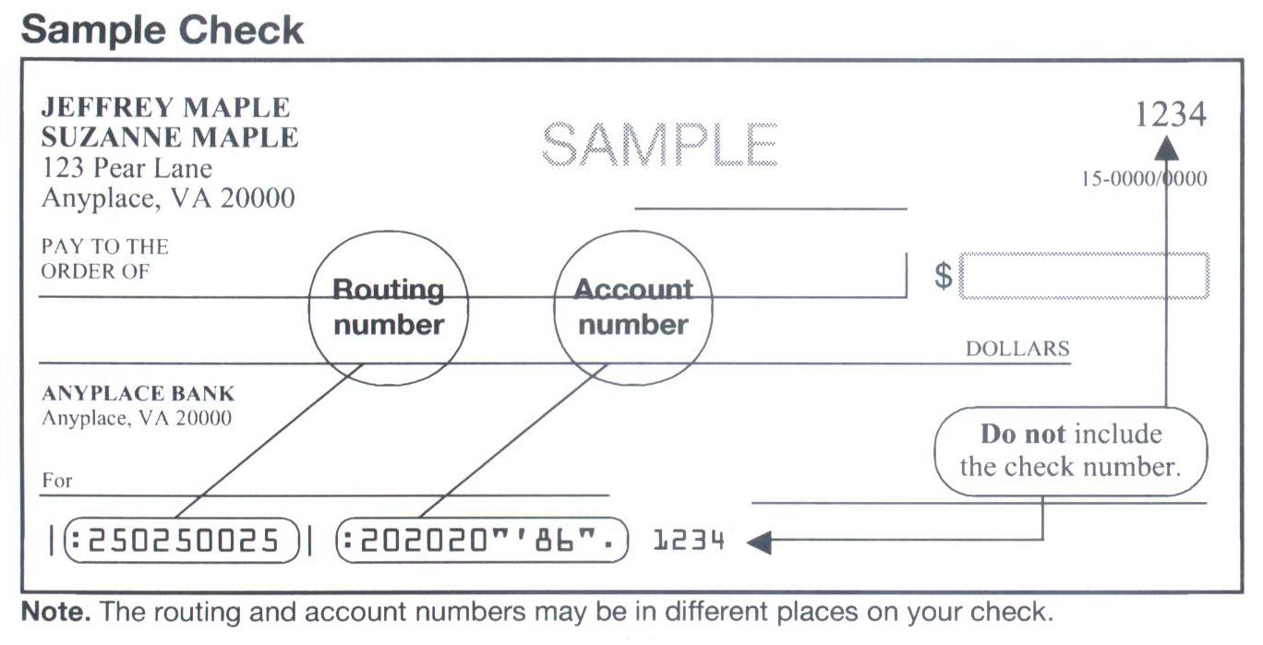
06/15

